Education is the passport to the future, for tomorrow belongs to those who prepare for it today.
Malcolm X

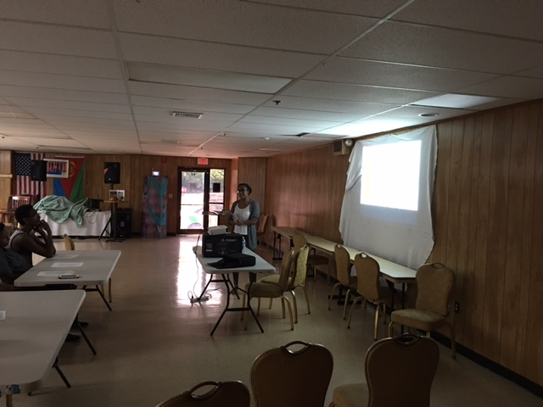

ECDC board members organized a seminar for Middle and High School students that reside in the Greater Boston area. The seminar was conducted by one of our own, Adel Andemeskel on August 20, 2017. Adel graduated from Stanford University this year, majoring in Biology. She now works in research at Brigham and Women’s, a Harvard affiliate Hospital in Boston, MA. She plans to join the Medical School in the near future.
The seminar focused on what students need to do while in High School. She highly advised students to be prepared early on. She emphasized that students need to build good relationship with their teachers. Recommendation letters that they get from the teachers is very important when they apply to colleges. She also challenged the students to take AP classes. Apparently, a grade of ‘B’ in AP classes has more weight than a grade of ‘A’ in less advanced classes when applying to colleges.
The second major topic Adel conveyed to the students was on when to apply to colleges. She advised student to work hard to maintain a high score in SAT and/or ACT. She told students in junior year to start working on their draft personal statement by the end of their junior year. She also advised senior year students to request recommendation letters during the fall of their senior year. This will give teachers ample time to write a good recommendation letter.
Once students are accepted to colleges and/or universities, she advised students to research about the schools. She also advised students to create the four year plan. She strongly advised students to get acquainted about everything the school has to offer through Facebook groups and school forums.
Last but not least, Adel encouraged students not give up when challenged with overwhelming classes. She advised students to get help from either the professor, TA’s or tutors immediately. To help college life balanced, Adel advised students to participate in extracurricular activities. Based on her personal experience, Adel advised students to get involved with any internship that they can get during their break time. The research position that Adel got offered at Brigham’s and Women’s Hospital is due to the fact that she did an internship with the Hospital while she was a student.
By and large, the seminar was very successful. It was very uplifting to see the students and parents getting involved in the open discussion. At the end of the seminar, Adel including Yohannes Daniel and Kesanet Tesfazion provided students with their contact information so that students can contact them in case they have any questions in the future. On behalf of ECDC, I would really like to thank Adel for taking her precious time to enlighten students and parents with plethora of information about the college application process.
